Asia-China-Coin-Bridge-3 in.

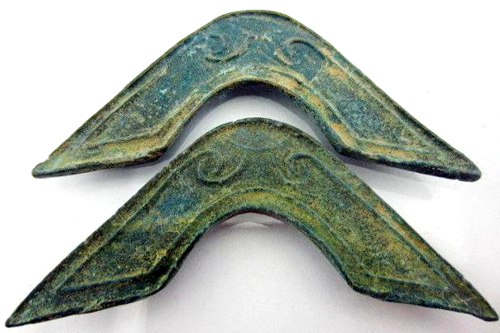

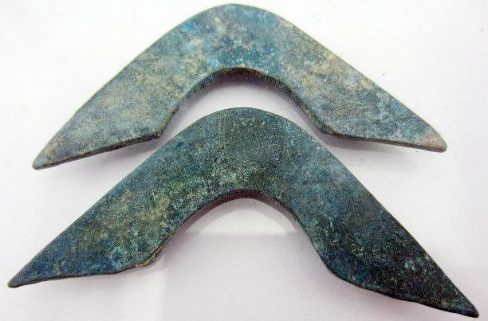

• weight: 29g

• size:  3.0*1.2 inches

Sold by

[8811my8](http://myworld.ebay.com/8811my8) ( [390](http://feedback.ebay.com/ws/eBayISAPI.dll?ViewFeedback&userid=8811my8)  )

+ Show additional actions

Delivery package 1 of 1

Estimated delivery Wednesday, Jan 8, 2014 - Thursday, Jan 16, 2014

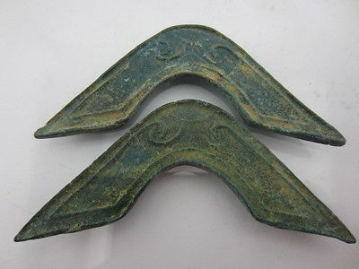

[Ancient Chinese bronze sculptures,tools of the trade, bridge shape,ancient font](http://www.ebay.com/itm/251406980286)

Item price

$4.99

Quantity

1

Item number

251406980286

Shipping service

ePacket delivery from China

[Leave feedback](http://feedback.ebay.com/ws/eBayISAPI.dll?LeaveFeedbackShow&useridfrom=802-867&useridto=8811my8&item=251406980286&transactid=0) [Contact seller](http://contact.ebay.com/ws/eBayISAPI.dll?FindAnswers&frm=3998&iid=251406980286&redirect=0&requested=8811my8) [Return item](http://return.ebay.com/ws/eBayISAPI.dll?ResolveReturn&eventName=viewSelectedItem&TransactionId=0&ItemId=251406980286)